
Name:_______________
Year 11 Modern History
Unit 1 Understanding the Modern World
Elective 7: Capitalism – the American Experience 1907–1941
PRACTICE Source Analysis

Conditions Marks: /25
Time for the task: 5 minutes reading time, 30 minutes working time.

- Compare and contrast the messages of Sources 1 and 2. (4 marks)
Hint: What does the creator want you to think, feel or believe for each of the sources (1 mark for stating what the message is for each of the sources)? What is similar about the sources (1 mark)? What is different about the sources (1 mark)?
__________________________________________________________________________________________________________________________________________________________________________________________________________________________________________________________________________________________________________________________________________________________________________________________________________________________________________________________________________________________________________________________________________________________________________________________________________________________________________________________________________________________________________________________________________________________________________________________________________________________________________________________________________________________
- Evaluate the usefulness of Sources 1 and 2 as representations of the attitudes towards changes in the USA in the 1920s. (5 marks)

Hint: Give a judgement on whether the two sources teaches us anything about the changes in attitudes in the 1920s. Provides examples of Source 1 as a representation of attitudes towards change (2 marks). Provides examples of Source 2 as a representation of attitudes towards change (2 marks). Evaluates the usefulness of the sources (1 mark).
______________________________________________________________________________________________________________________________________________________________________________________________________________________________________________________________________________________________________________________________________________________________________________________________________________________________________________________________________________________________________________________________________________________________________________________________________________________________________________________________________________________________________________________________________________________________________________________________________________________________________________________________________________________________________________________________________________________________________________________________________________________________________________________________________________________________________________________________________________________________________________________________________________________________________________________________________________________________________________________________________________________________________________

- Identify and account for the authors’ perspectives in Sources 1 and 2 regarding the specific changes described in the documents. (6 marks)
Hint: What is the viewpoint of the creator? Articulates the perspective of Source 1 (1 mark). Articulates the perspective of Source 2 (1 mark). Analyses of the perspectives in relation to the question asked which may include discussion of motives, bias, time, place, purpose (4 marks).
____________________________________________________________________________________________________________________________________________________________________________________________________________________________________________________________________________________________________________________________________________________________________________________________________________________________________________________________________________________________________________________________________________________________________________________________________________________________________________________________________________________________________________________________________________________________________________________________________________________________________________________________________________________________________________________________________________________________________________________________________________________________________________________________________________________________________________________________________________________________________________________________________________________________________________________________________________________________________________________________________________________________________________________________________________________________________________________________________________________________________________________________________________________________________________________________________________________________________________________________________________________________________________________________________________________________________________________
- Explain the historical context of Source 2. (4 marks)
Hint: what, when, cause, effect (1 mark each). Focus on what is in the source and explain the relevance/significance.
______________________________________________________________________________________________________________________________________________________________________________________________________________________________________________________________________________________________________________________________________________________________________________________________________________________________________________________________________________________________________________________________________________________________________________________________________________________________________________________________________________________________________________________________

- Evaluate the extent to which the two sources give an accurate insight into the significance of the 1920s as a period of change in the USA. (6 marks)
Hint: Make a judgement on how the four sources teach us about the 1920s as a period of change. Articulates the different aspects of change that are shown (1 mark). Identifies aspects of change that have been omitted (1 mark). Evaluates the extent to which the sources reflect the significance of the changes depicted in the sources in terms of the 1920s as a period of change in the USA (3 marks).
________________________________________________________________________________________________________________________________________________________________________________________________________________________________________________________________________________________________________________________________________________________________________________________________________________________________________________________________________________________________________________________________________________________________________________________________________________________________________________________________________________________________________________________________________________________________________________________________________________________________________________________________________________________________________________________________________________________________________________________________________________________________________________________________________________________________________________________________________________________________________________________________________________________________________________________________________________________________________________________________________________________________________________________________________________________________________________________________________________________________________________________________________________________________________________________________________________________
Source Booklet
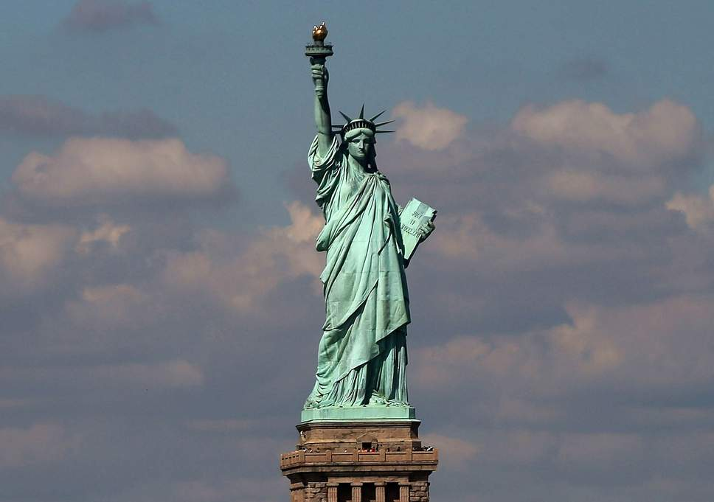
Source 1: The Statue of Liberty. Carved at the base of the statue was a poem by Emma Lazarus written in 1886.

“Give me your tired, your poor,
Your huddled masses yearning to breathe free
The wretched refuse of your teeming shore.
Send these, the homeless, tempest-tossed to me;
I lift my lamp beside the golden door.”

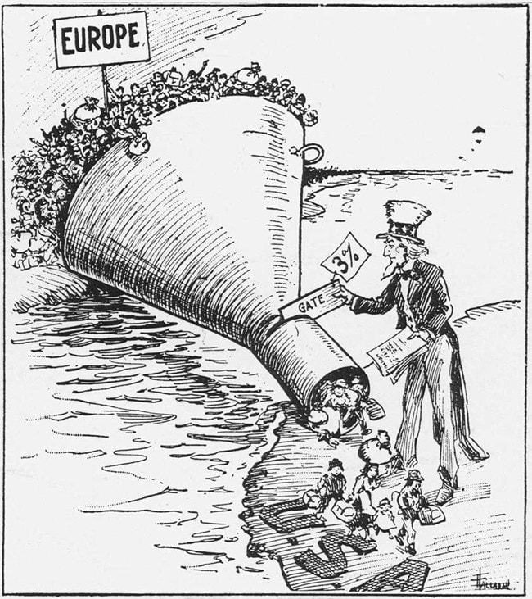
Source 2: A 1921 political cartoon portrays America’s new immigration quotas, influenced by popular anti-immigrant and nativist sentiment stemming from World War I conflict.

Name:_______________ /25
Practice Source Analysis – MARKING KEY
Marking key:
- Compare and contrast the messages of Sources 1 and 2.
Description | Marks
Reference to the messages in Source 1 and Source 2 | 1–2
Points of comparison of the messages in Source 1 and Source 2 | 1
Points of contrast of the messages in Source 1 and Source 2 | 1
Total | /4
Note: Evidence should be identified from the sources to support messages.

(b) Evaluate the usefulness of Sources 1 and 2 as representations of the attitudes towards changes in the USA in the 1920s.
Description | Marks
Provides examples of Source 1 as a representation of attitudes towards change | 1–2
Provides examples of Source 2 as a representation of attitudes towards change | 1–2
Evaluates the usefulness of the sources | 1
Total | /5
Note: The response should include, where appropriate, both the strengths and weaknesses of the sources provided, in terms of how they are representative of attitudes towards changes in the USA in the 1920s.

(c) Explain the historical context of Source 4.
Description | Marks
Identifies the focus of the source | 1
Outlines the causes or events that led to the focus of the source | 1
Provides specific details for the focus of the source, dates/events/people/place/ideas | 1–2
Total | /4
Note: This question is concerned with the historical context in which the source is located. The answer must concentrate on what is in the source and explain the relevance/significance.

(d) Identify and account for the authors’ perspectives in Sources 1 and 2 regarding the specific changes described in the documents.
Description | Marks
Articulates the perspective of Source 1 | 1
Articulates the perspective of Source 2 | 1
Analyses of the perspectives in relation to the question asked. This may include discussion of:  • motives  • bias  • time  • place  • purpose | 1–4
Total | /6
Note: The response should:
- analyse the perspectives of the sources in terms of the theme/force
- articulate the perspectives from which the sources were constructed or analyse reasons for the perspective (purpose/motive/place/and time)
- use evidence of the perspective from the source
- identify how the author shows the perspective in the source.

e) Evaluate the extent to which the two sources give an accurate insight into the significance of the 1920s as a period of change in the USA.
Description | Marks
Articulates the different aspects of change that are shown. | 2
Identifies aspects of change that have been omitted. | 1
Evaluates the extent to which the sources reflect the significance of the changes depicted in the sources in terms of the 1920s as a period of change in the USA. | 1–3
Total | /6
Note: The response should:
- focus on what the sources say about change within the context studied, and why it may have been significant to highlight this
- include the implication/impact of these changes on American society in the 1920s
- include the student’s own knowledge of the 1920s to support their point of view.

